**Practical 6 : Concepts of fork() and exec().**

**Fork examples:**

**Code1:**

#include<stdio.h> #include<sys/types.h> #include<unistd.h> int main()

{ int id=fork(); printf("parent:%d %d %d",id,getpid(),getppid()); }

**Code2:**

#include<stdio.h> #include<sys/types.h> #include<unistd.h> int main()

{ int id=fork(); if(id!=0)

{ sleep(5);

} printf("parent:%d %d %d",id,getpid(),getppid()); }

**Output:**

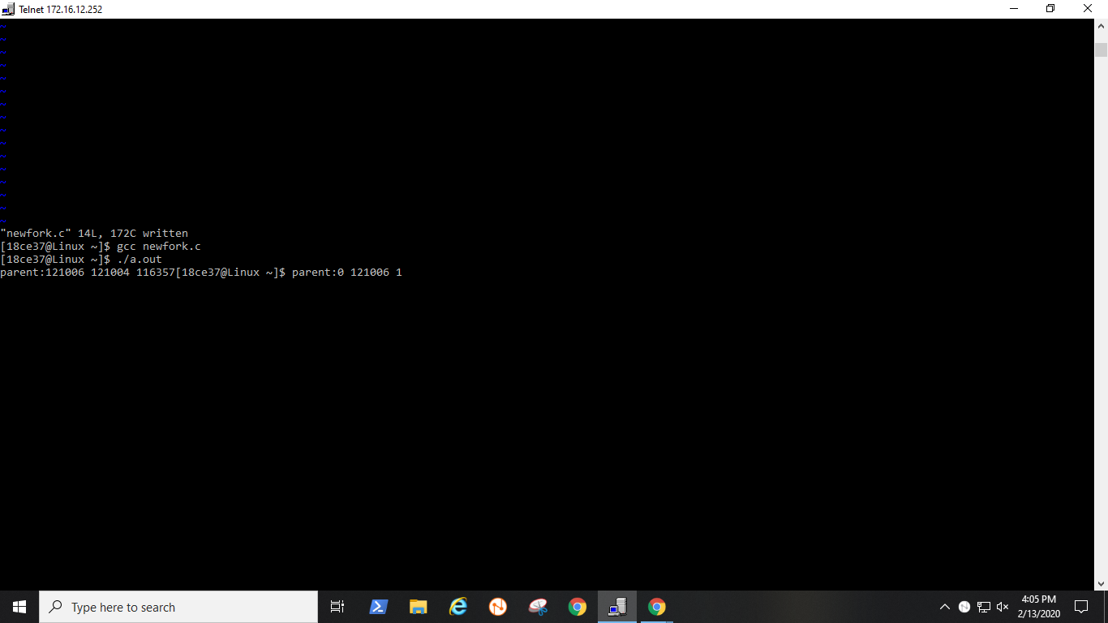

**Exec examples:**

**Exec.c**

#include<unistd.h> #include<sys/types.h> #include<stdio.h>

int main() { execv("./exec",NULL); printf("hello\n");

}

**Newexec.c**

#include<stdio.h>

int main()

{

printf("temp file\n");

}

**Output:**

